**UNLEASHING THE POTENTIAL OF ELECTRONIC NOSE TECHNOLOGY FOR THE FUTURE OF AGRICULTURE**

1Manyam Jaswanth, 2Matcha Bhavana, 3Vigneswari S

1,2 Student, 3 Head of the Department

Sathyabama Institute of Science and Technology

Chennai, India

1 [jaswanthchowdary.456@gmail.com](mailto:jaswanthchowdary.456@gmail.com) , 2 [bhavanamatcha2004@gmail.com](mailto:bhavanamatcha2004@gmail.com) , 3 [vikiraju@gmail.com](mailto:vikiraju@gmail.com)

***Abstract-* Internet of Things is integrated with intelligent Electronic Noses which represents the leading changes in contemporary agriculture. Electronic Noses are supposed to mimic human sense, which is smell, and therefore designed to detect and analyze the extensive patterns of odor as well as Volatile Organic Compounds with more precision. The paper revolves around how Electronic Noses are fundamental in three Agricultural applications, which include: Fruit Ripeness Detection, Climate Change Monitoring, and Harmful Gases identification. From agricultural application of fruit ripeness detection, e-noses provide the necessary non-intrusive crop maturity monitoring by ensuring that the fruits are harvested at the prime quality. This feature aims in enhancing the efficiency in harvesting and also reduces losses to waste as a result of lessened possibilities of selecting fruit and vegetables as under-ripened or rotten. For climate change monitoring, e-noses are utilized in the IoT systems that track shifts in environmental parameter changes, such as alterations in atmospheric composition that indicate greater climate trends. The systems contribute to an understanding of how agricultural practices impact climate change. Deployment of e-noses in agricultural environments has been used in the area of harmful gas detection, monitoring ammonia, hydrogen sulfide, and carbon monoxide among hazardous gases. Early detection of such gases safeguards from the potential health risks to both workers and livestock; it also ensures the safety as well as quality of the produce. Electronic noses are integrated into the structures of IoT allow continuous, real-time monitoring of such critical factors. Those systems provide actionable insights and support more informed decision making, which leads to optimized resource use, improved crop quality, and environmental sustainability.**

***Keywords- Internet of Things, Electronic Nose, Fruit Ripeness Detection, Climate change Monitoring, Harmful Gas Detection.***

1. **INTRODUCTION**

Agriculture forms the base of human life, as it serves as a cornerstone to provide food, employment opportunities, and security in economy. Being a prerequisite for food security, agriculture provides a vast range of crops, livestock that have greatly contributed to human nutrition and well-being. Agriculture has ultimately emerged from the domestication of plants and animals through modern means which have elevated their productivity to considerable levels. Nevertheless, the agricultural sector has challenges that not only jeopardize its sustainability but also render it ineffective. One of the major issues is how to determine fruit ripeness: this depends significantly on consumer satisfaction and, thus, value at market. Traditionally, ripeness would be determined subjectively based on color and firmness. However, these features are highly variable under conditions of environment and per individual perception. During unfavourable seasons, premature harvesting sometimes results to low quality while late harvesting results in over-ripeness and wastage. Thus, farmers seek reliable and objective fruit ripeness evaluation. Another challenge to agriculture is climate change. The agricultural sector is very sensitive to changes in climate; with temperature and precipitation patterns influencing the crop growth and yield in the rest of the world. Climate change, besides affects the growing conditions, also increases the prevalence of extreme weather events, which may be very inimical to crops. Plants typically release specific Volatile Organic Compounds in response to environmental stresses. Monitoring such gases can provide worthwhile information on the health status of the plants and even allow farmers to take timely measures against some adverse impacts.

In addition, agriculture requires other toxic emission. Such gases like ammonia and hydrogen sulfide can indicate lower crop health due to degrading soil or pest infestation. Detection of such toxic emissions needs to be done because they may result in quite serious declines in yield and quality. Traditional detection requires labor and at times does not give accurate data, hence not saving the farmer from the threat. Thus, electronic noses emerged as new innovations within the agriculture sector. Electronic noses are advanced devices as they mimic human senses of smell, that help in the detection and analysis of the VOCs in the environment.

In the case of fruit ripeness detection, E-noses can precisely evaluate the specific aroma compounds that emanate when fruits ripen. By offering objective assessments of ripeness, e-noses can contribute to minimizing waste and maximizing marketability, thereby benefiting producers and consumers alike. This technology can be employed by farmers to decide when fruits should be harvested for the maximum quality, nutritional value, and appeal. To monitor climate change, an e-nose can be utilized as a tool for the detection of stress-related gases released by plants based on conditions present in the environment. Farmers will gain crop health information while taking correct decisions concerning irrigation, fertilization or pest management. The proactive aspect of this will make farmers adapt their practices in ways to mitigate adverse climate change impacts and ensure sustainable agricultural production. E-noses also contribute to the detection of harmful gases. Monitoring volatile emissions, such as ammonia and hydrogen sulfide, gives e-noses the ability to inform farmers instantly of information regarding soil health and potential pest threats. This timely information allows for quick interventions, reducing the need for chemical treatments and promoting more sustainable agricultural practices. The application of e-nose technology in agriculture has changed the face of problems bordering around fruit ripeness and those bordering on climate change among others because it detects harmful gases. It in turn enhance productivity, promote sustainability, and increase the farmer's contribution to a more resilient agricultural system.

1. **LITERATURE SURVEY**

**Electronic-Nose Applications for Fruit Identification, Ripeness, and Quality Grading, 2015.** Fruits have a vast variety of VOCs, which confer a different flavor and aroma, influencing the acceptance of a product by its consumer. Traditionally, sensory attributes have been rated by human testers who test the quality of fruits based on smell and taste. These assessment techniques are subjective and do vary in different testing. The efficiencies and thrifty nature with which e-noses can then be used to assess fruit quality rest on the fact that they were designed to carry certain arrays of sensors capable of detecting and analyzing complex VOC mixtures produced by fruits. The "fingerprints" of these volatile profiles thus enable proper identification of the types of fruits, differentiation between cultivars, evaluation of ripeness, and grading of fruit quality. E-noses will serve as an objective, real-time source of information on fruit attributes hence enhancing the quality control of the industry. They will enable the farmer to determine the optimal harvest time based on the real-time monitoring of ripening, assessment of storage conditions, and shelf-life prediction. This improves operational efficiency, provides consistent quality in fruits, and reduces wastes, which is supportive of better decisions on fruit production and marketing. [1]

**Electronic Nose Assessment for Fruit Ripeness, 2005.** This article discusses whether electronic noses can be useful in the non-destructive testing of fruit maturity. In fact, this study analyzed some of the fruits, like peaches and nectarines, apples, and pears to comparatively evaluate in how far e-noses prove as compared to the traditional ones. E-noses measure the VOCs emitted by fruits, which change at different levels of ripening. Other quality indicators used to determine a reference point of comparison were firmness, sugar contents, and acidity. Results: Measurements by the e-nose shared much correlation with the established ripeness indicators, meaning that e-noses can be efficiently used to record the changes in VOC profiles as related to different stages of fruit ripeness. The results show that the e-noses can accurately predict the time for harvesting fruits at an optimal maturity because they give real-time insights into fruit ripeness. This further proved useful for monitoring the ripening process during storage, thereby ensuring fruit quality and reduction of fruit waste. It is a non-destructive approach that proved promising in replacing traditional ripeness assessment methods for fruit quality management in terms of accuracy and efficiency. [2]

**Review for Food Freshness using Electronic Nose and its Classification method, 2018.** Electronic noses (e-noses) are advanced sensors used to mimic the human nose and are widely applied for detecting and discriminating between different odors, gases, and VOCs from contaminants and release of substances such as food. They are provided with sensor arrays that react specifically to particular aroma molecules, hence capturing detailed data of gases and odor concentration in the sample. Sensors interact with volatile compounds, and for each type of VOC, a unique response pattern is generated. Then, the process sensor data is evaluated by the signal processing unit to recognize patterns of VOCs and make classifications based upon the pre-stored information in databases. Classification of patterns of the odor enables specific combinations to be detected for the purpose of determining food freshness. Once the VOC patterns are compared with known standards, e-noses can sense any changes that reflect spoilage or degradation, thus providing a reliable and non-destructive means of measuring food quality. This technology ensures the efficiency through which quality control is done and accurate freshness assessment. [3]

**Application of Electronic Noses for Disease Diagnosis and Food Spoilage Detection, 2006.** The paper discusses the way electronic noses, or e-noses, are revolutionizing the detection of microbial volatiles for disease diagnosis and managing food spoilage. During the last two decades, e-noses have become very important tools for the fast, non-invasive odor analysis in medicine and the food industry. Advantages of employing the e-noses are advanced sensor technologies incorporated in them enable them to detect and quantify VOCs released by bacteria and fungi. As VOCs are an excellent indicator of microbial activity, their presence would be indicative of an infection or food spoilage. Several studies discussed in the review illustrate the efficacy of these e-noses in discerning between volatile profiles associated with specific pathogens and spoilage conditions. This function ensures early detection and accurate diagnosis, thus offering significant improvements over the conventional methods. E-noses enhance the efficiency and reliability of microbial detection, thus serving as a robust approach to managing healthcare and food safety challenges. The paper discusses the transformative capacity of e-noses in advancing diagnostic accuracy and food quality control and leads to the potential for risks resulting from microbial contamination to be mitigated. [4]

**Monitoring Food Spoilage with Electronic Nose: Potential Applications for Smart Homes, 2009.** The review here discussed the use of electronic noses (e-noses) in monitoring food spoilage in the smart home, focusing particularly on research applying a commercial e-nose fitted with a commercial sensor platform using arrays of metal-oxide sensors. The authors followed the time course of odor evolution in five foods over seven days and observed that, in this period, e-nose reportedly distinguished fresh from spoiled items. At the progressive stages of spoilage, the device obtained major variations in odor profiles, analyzed using principal component analysis, where clear trajectories can be seen quite linearly for the different stages of spoilage. The review brings attention to the promise that e-nose technology might carry toward early and accurate detection of food spoilage in smart homes with a view toward proactive approaches to food safety and prevention of waste. However, some of the challenges identified in this review include sensor stability, user interaction friendliness, and costing. All these require to be addressed for successful adoption and incorporation of the technology in food management at home. They will lead to more dependable and efficient spoilage detection in homes. [5]

**Application and Limitation of Electronic Noses in Plant Disease Detection, 2017.** The application of electronic noses technology is a non-destructive method through which plant diseases and pests can easily be detected using sensor arrays analyzing bulk samples of plant material for volatile organic compounds emitted by plants since they would change due to disease or pest infestation. This method is very simple, making it easy to manage and fast for analysis, which is really quite appealing for routine monitoring and early detection. Yet, electronic noses have some limitations, especially concerning their sensitivity and specificity in comparison with traditional microbiological and molecular diagnostic techniques. Reading through such drawbacks enlightens the reader that on some occasions the e-noses fail to detect differences in VOC fingerprints related to specific plant diseases or infestations by pests. Despite all these, continuous improvement in sensing technology and data analysis is going to achieve better discrimination between the healthy and infected plant. In general, the review indicates that, despite the importance of electronic noses, their values only complement the traditional diagnostic approaches and not opposition. Electronic noses work best with the currently available methods rather than replacing them. This integrated approach increases diagnostic accuracy and gives a more comprehensive set of toolkits for plant disease and pest management. [6]

**Intelligent Electronic Nose System for Basal Stem Rot Disease Detection, 2009.** This paper discusses electronic nose technology combined with artificial intelligence to improve the detection of basal stem rot disease, caused by the fungus, on oil palm plantations. This disease was, up to now, characteristically diagnosed through human discriminatory sense of smell towards smells associated with infection, which may vary in very subjective nature and liable to operator fatigue. They collected odor samples of oil palms at the Besout plantation in Malaysia and submitted these into a computer system for analysis. The results established that the AI-enhanced e-nose system could effectively differentiate between the kinds of types of odor emitted by a healthy and infected oil palm plant. This method may show how electronic noses, combined with artificial intelligence, can be used to improve the accuracies and dependability of plant disease detection and advance an important step in advancing disease control of agriculture. [7]

**Elecrnic Nose based on Metal oxide semiconductor** **sensors for detecting crop disease and insect pests, 2022.** It is a literature survey dealing with the application of e-noses with MOS sensors in crop disease and pest detection. Traditional methods of pest control, such as use of pesticides, have caused severe environmental and health problems, thus calling for alternatives that are more environmentally friendly and sustainable in terms of detection technologies. Technologies emulating the animal's olfactory systems, such as the e-nose, are non-destructive, relatively inexpensive, and very sensitive to VOCs emitted by crops at the time of pest infestation and disease outbreaks. These specific MOS sensors are interesting in their cross-sensitivity, wide range of responses, and relatively low-cost, thus forming a goldmine for applications in e-nose arrays. They could recognize significant differences in VOC emissions from plants, which would be determined by the presence or absence of diseases or pests. The review discusses mainly the main principles of MOS e-nose technology, latest technological advances, and practice in crop disease and pest management. This is aimed at improving understanding and providing useful knowledge to the technology of crop health monitoring and pest control by giving insights into how MOS e-noses can be integrated into agricultural practices. [8]

**Detection of Insect Infestations in Paddy Field using Electronic Nose, 2011.** This work studied the possibility of using electronic nose technology for predicting the levels of insect infestation and storage time in paddy rice. For the analysis of the stored paddy rice samples that might be different in type and even intensity depending on the infestation level and storage time, the electronic nose for volatile compounds released was used. In an attempt to prove the electronic nose capability, PCA, as multivariate statistical methods have been applied. These methods validated the ability of the e-nose to differentiate between rice samples depending on the level of infestation and storage time. More advanced analytical techniques, including PLS and BPNN, were utilized in order to maximize the predictions associated with the infestation index and the storage duration. Amongst these, BPNN presented the most accurate predictions related to both parameters. The authors conclude that electronic nose technology has tremendous potential for a precise evaluation of the level of infestation and the storage time of the stored paddy rice, thereby establishing a valuable tool in managing and monitoring grain quality based on sensor data. [9]

**Development of a Portable Electronic Nose for pests and plant damage, 2014.** The 2014 survey investigates the development of a portable electronic nose (e-nose) specifically designed for detecting agricultural pests and evaluating plant damage. This e-nose makes use of carbon black–polymer composite sensors to detect VOCs emitted by pests or stressed plants. The device allows one to immediately and non-destructively observe whether pests exist and in what quantities through measurement of the changes in electrical resistance of these sensors when exposed to a variety of VOCs. The technology provides several practicable advantages: in real time monitoring crop health detection of pest infestation at early stages, and the evaluation of plant injury without damaging any of the crops. It therefore facilitates improvement in pest control tactics by allowing timely interventions and enhances crop management practices. Moreover, further advancement of e-nose technology may save the loss of economy due to pest damage, having an overall positive impact on increasing agricultural productivity and sustainability of crops. Even additional steps may be driven in order to enhance sensor sensitivity, accuracy, and durability in order to bring more practical e-noses into the agricultural environment. [10]

**Monitoring plant pest and disease using discrimination of plant volatile signatures by an electronic nose, 2008.** This study exploits the possibilities for using e-nose technology for the discrimination of plant VOC profiles produced in response to applied stress conditions, including mechanical damage, infestation by pests, and disease. Each e-nose has sensor arrays sensitized to the detection of many different VOCs-always associated with the plant response to its stressors. Such analyses of these VOCs allow for the clear and precise identification of very subtle differences in the chemical signatures produced by plants under different conditions; real-time health monitoring and assessment of plants are thus made possible, allowing timely determination of problems and diagnosis. It is shown that the e-noses can distinguish VOC profiles related to mechanical damage, pest activity, and disease; therefore, it provides information to improve management practice. The ability to detect VOCs associated with stress enhances the possibility of early interventions, advances pest and disease control strategies, and supports more informed decision-making in the agricultural environment. Such high-resolution monitoring and evaluation also result in healthier plants and better agricultural practices, thereby indicating huge promise for e-nose technology in improving agricultural health and productivity. [12]

**Tomato Plant Health Monitoring by Electronic Nose Approach, 2011.** The book elaborates on using e-noses to monitor the health of tomato plants and to identify diseases in greenhouse environments. It describes the use of an advanced 13-sensor e-nose system with the intention of sensing and analyzing the released VOCs from the tomato plants. The paper attempts to interpret VOC data through advanced analytical techniques, such as PCA and Grey System Theory. PCA simplifies the data by identifying predominant patterns and trends pertaining to health of plants, whereas Grey System Theory is given when there is uncertain or incomplete data that needs to be managed and analyzed for outcomes to be robust. Results from pre-study provide promise that technology concerning e-nose is efficient in early detection of health problems related to the plants as well as continuous monitoring thus a powerful tool in proactive management of greenhouses. It senses specific VOC profiles related to health issues, thus enabling timely intervention for possible better disease management and productive utilization of tomato crops. The author explains how e-noses can be employed for modernization in greenhouse practice and advancement of plant health monitoring. [13]

**Technological progress in gas sensors and electronic nose towards agricultural cycle uses, 2022.** This review paper discussed the development of technologies of gas sensors and electronic nose (e-nose) and their use in multiple stages of the agricultural cycle-wintering, growth, harvesting, and storage-in countering problems associated with climate change while also enhancing crop management skills. These sensor and e-nose technologies have several benefits that are incorporated into agricultural systems, including better monitoring of environmental conditions, early detection of plant diseases and pests, and improved use of resources-mutation: water and fertilizers. Gas sensors and e-noses can provide real-time information on VOCs and other gases that support more informed decisions and preventive measures. However, it also incorporates the weaknesses and constraints of the technologies. These are considered as shortcomings in the accuracy of the sensors, reliability and calibration robustness. In this context, the review focuses on the potential of gas sensors and e-noses in current agriculture by stressing and underlining the necessity for further research and development to reap their full potential and overcome current challenges. [14]

**11 - Sensors and electronic noses for the production of agricultural crops, 2023.** The chapter underscores the critical role of sensors and electronic noses (e-noses) in agricultural production, particularly for monitoring field conditions, crop growth, and product quality. This paper gives an overview of the broad use of these technologies in crop yield and ultimately, agricultural productivity assessment. The discussion tracks several critical factors that sensors and e-noses can provide monitoring processes in soil water levels, soil types, temperatures, and usage of pesticides and chemical fertilizers. Such factors all have a great impact on crop growth and yield, hence care in sensing provides better management and optimizing of agricultural practices. For example, it can sense immediate information about soil moisture levels so that appropriate modifications can be done on irrigation practices. An e-nose can detect volatile organic compounds related to plant health and soil conditions. This chapter gives an overview of the development and application of various types of solid-state sensors applied in agriculture. These sensors are essential in assessing agricultural suitability, monitoring the quality of soil, and other changes that could affect crop health. The reason why solid-state sensors-good for response and robustness-are important for crop quality improvement and sustainable agriculture is explained. Opportunities and challenges are also discussed in integrating these technologies into the already established agricultural systems, which is part of this chapter. It has huge potential applications in agriculture towards improving crop management and productivity, though challenges include cost, sensor calibration, and data interpretation as major rigors. In this respect, the chapter highlights continuing innovations, therefore, and thus continuation in investment into innovativeness for full exploitation of these technologies in modern farming. [15]

**Electronic Noses for Environmental Monitoring Applications, 2014.** The review of e-noses in 2014 has brought out the current importance of these devices in environmental monitoring and further underlined their extensive applicability to gas as well as odor detection and discrimination. E-noses are increasingly finding several applications such as determination of environment quality, pollution monitoring, as well as industrial process monitoring. They provide the flexibility to examine a wide range of VOCs, and hence, find applicability in air quality assessment and source identification. However, the key limitations toward more extensive usage include its complex calibration process, lack of a global standard measurement in the field, and variations in sensor properties. To address these, developments are currently made on the strength and accuracy of the technology. Standardized testing procedures and reliability of sensor also play a role in increasing practical application and efficiency of e-noses in environmental monitoring applications. Hence, the developments are toward accurate and reliable detection of events as much as possible for improving control over the pollution. [16]

**Emerging Wearable Sensors for Plant Health Monitoring, 2021.** The article describes the research into the development and application of wearable sensors for monitoring plant health amidst growing threats from diseases, pests, and climatic changes by means of an innovative design applied to placement on plant surfaces to recognize a wide variety of biomarkers and environmental conditions. These wearable sensors will allow one to provide real-time data necessary for interventions and informed decision-making in agriculture. The review categorizes the sensor devices under the particular functions such as plant growth monitoring, physiological responses, microclimatic conditions, and chemical parameters. Recent developments in sensor technology along with improvements have been discussed here to show how these innovations contribute significantly in more effective and precise management of plant health in precision agriculture. Present the challenges currently faced by wearable sensors, including their integration into existing agricultural practices, durability of sensors, and interpretation of data. The review culminates in discussion on future prospects that would require extensive research and development toward overcoming the above challenges to enhance the utility of wearable sensors in sustainable agriculture. [17]

**Future Perspectives of Plant Volatile Organic Compounds Research: Advances and Applications for Sustainable Agriculture, 2022.** Plant volatiles form an essential part of plant defense systems against various environmental stresses, including attacks from herbivores. Most relevant to this are herbivore-induced plant volatiles, otherwise known as HIPVs, which have a dual role of deterring herbivores from feeding on the plants and attracting natural predators or parasitoids that prey on these pests. This is a natural defence mechanism, which will provide the essential health to plants and reduce dependency on chemical pesticides. Multisensor arrays have significantly enhanced the latest technological developments in the identification and quantitation of pVOCs. Advanced tools may offer more accurate and timely determinations of volatile compounds emitted from a stressed plant. This would enable researchers to diagnose earlier and more accurately the stress in plants, thus allowing an updated strategy in the management of pests in crops as well as crop protection. These developments also contribute to stronger crops and to higher crop yields that can be produced sustainably. The continuing development of research on pVOC clearly represents a critical development towards creating novel solutions for food production in agriculture-although present environmental changes increase the challenges posed by enhancing general crop health and productivity. [18]

**Electronic Nose for Pesticides: The First Study Towards a Smart Analysis, 2019.** This study centers on the development of an electronic nose (e-nose) specifically tailored for the detection of pesticides using commercial gas sensors. The e-nose was designed as an integral part of a smart monitoring system intended for use in agriculture. It aims to measure and quantify pesticide residues in the environment based on the quantification of VOCs corresponding to these chemicals. Preliminary tests on the e-nose have yielded positive results, showing the capability to differentiate between pesticide-related VOCs to a reasonable level of accuracy. The preliminary testing conducted henceforth disclosed the possibility that the e-nose will be an effective tool in pesticide monitoring and management of agricultural land. However, there remains a call for its further development. This subsequent study, therefore, primarily seeks calibration testing to hence make the system finer and more precise. Thereby, this process of continuous development will optimize the performance of the e-nose; thus, it could become a faithful data source for effective and safe pesticide management in the environment. [19]

1. **SYSTEM ARCHITECTURE**

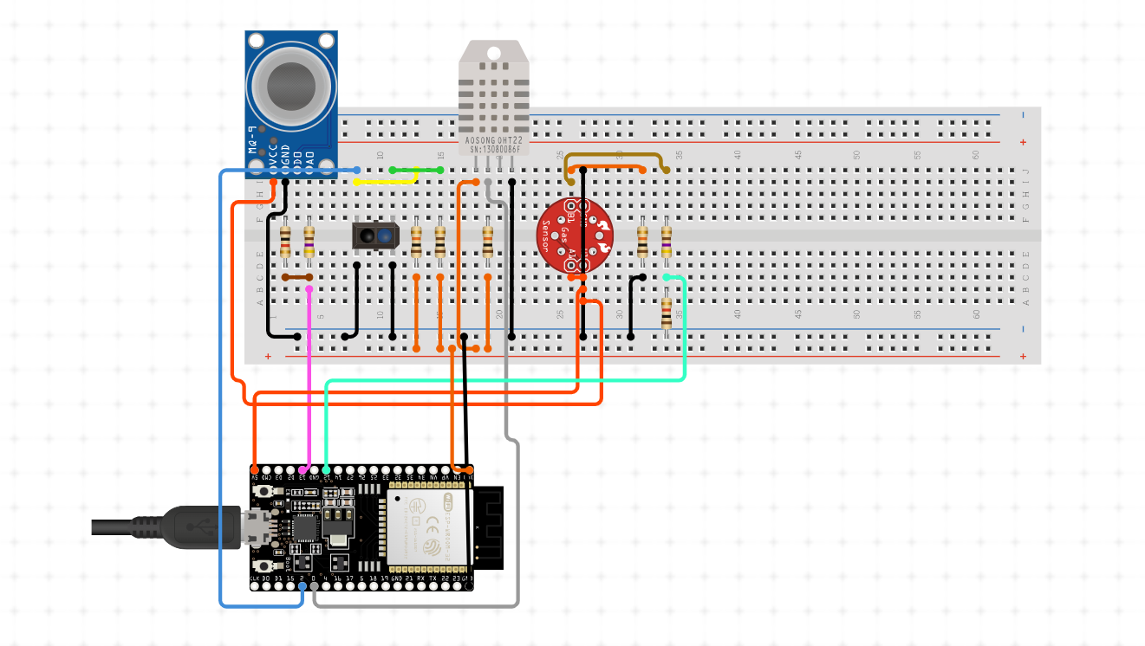

1. **WORK FLOW**

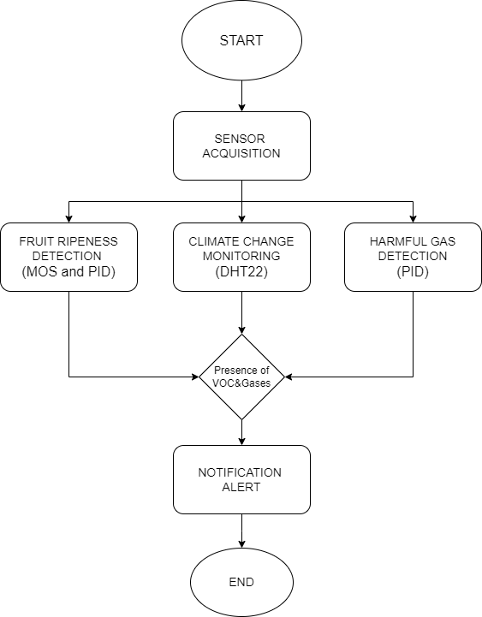

1. **RESULTS AND DISCUSSION**

The technological advancement of the e-nose in smart agriculture use has made tremendous progress in detection fruit ripeness, climate monitoring, and also harmful gas detection. The three categories of sensors arrayed in the e-noses, such as MOS sensors, PID, and temperature-humidity sensors, have been observed and proved effective in the identification of the ripeness of fruits based on specific VOCs emitted during the ripening process. For instance, the capability to detect production in fruits such as bananas and tomatoes enables better harvesting times, hence attaining qualitative improvements in the fruiting plants that eventually translate to losses reduction. Secondly, e-noses, they have proved themselves to be very helpful in plant stress monitoring as an effect of climatic change; detecting gas related to stress, which may hint towards undesirable conditions for crops, allows farmers to alter such conditions, irrigation schedules, and pest management. As such, regarding the detection of noxious gases, the PID and MOS sensors of e-nose systems have done well in identifying gases such as ammonia and hydrogen sulfide and, therefore, indicate the soil's health status or potential pest problems. This capability helps in taking timely interventions while reducing their use of chemical treatments that may ignite their adoption of sustainable agricultural practices. Overall, the outcome suggests that e-nose technology is crucial for the enhancement of agricultural productivity along with ensuring food security and environmental sustainability in the face of emerging agricultural challenges.

1. **CONCLUSION**

Intergrading e-nose technology with smart agriculture represents a revolutionary approach that deals with the critical challenges of detection of fruit ripeness, monitoring of climate change, and detection of harmful gases. With advanced sensors like MOS, PID, and temperature-humidity sensors, the highly accurate measurement can be real-time in nature, enabling farmers to always take sound judgment decisions. The real-time monitoring of fruit ripening enhances marketability and minimizes waste, while observing plant stress due to climate change helps in implementing advanced management decisions for the health of the crops and their yield. Moreover, the detection of harmful gases supports sustainability by reducing chemical interventions and environmental safety. Given the rising agricultural demands and intensification of environmental issues, a sustainable agriculture system is going to highly depend on e-nose technology that ensures systems for improved productivity, at the same time ensuring farming systems are resilient to change.